**Parameter Estimation of Electric Machines – Review**

Prepared by Serhat OZKUCUK

In this report, modeling, parameter identification and estimation of electric machines (synchronous, induction, switched reluctance) are searched and core aspects and some special techniques are summarized.

**1. Introduction**

Modeling the dynamism of a system has a critical role for designing the control system. Modeling often results in a parametric model of the system which contains several unknown parameters. Experimental data are needed to estimate the unknown parameters. Generally, the parameter estimation from test data can be done in frequency-domain (noise-corrupted data are used for estimation) or time domain (maximum likelihood technique for remove the noise effect from estimated parameter in frequency domain).

**2. The effect of noise on frequency domain parameter estimation of synchronous machine**

Modeling and estimation works done via 2nd (SSFR2) or 3rd (SSFR3) order model structure (they are not enough for exact mathematical representation) that assuming there are two or three rotor winding model is used in estimation of machine parameter from test data, but, there are an infinite number of rotor circuit. So, even if it is assumed that model is correct, estimated parameters will not unique that are obtained from measurement (noise corrupted frequency response data is obtained from complex actual high order rotor circuitry machine that has unknown structure and parameters). In this case, simulated model response and the measured response will be different due to noise. Therefore, the structural identification problem and the parameter estimation problem should be studied separately. There is a need to show that the measurements noise will not corrupt the estimated parameters when the parameters of an assumed structure are estimated from the frequency response measurements.

For this purpose,

Step 1: Stand-Still Freq. Resp. SSFR3 3rd order model with known parameters is simulated then, obtained data is being noise-corrupted by a known noise distribution.

Step 2: Estimate the parameters of this model from the noise-corrupted data and compare with the known parameter in Step 1.

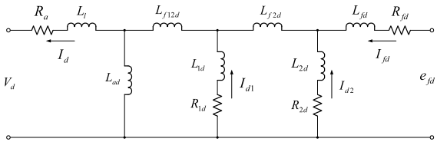 (d-axis eq. circuit of SSFR3)

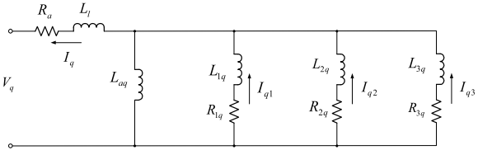(q-axis eq. circuit of SSFR3)

*This model can be reduce 2nd or 1st order with throwing away parallel paths.

**2.1. Parameter Estimation Technique**

Transfer function of the d-axis SSFR3 eq. circuit:

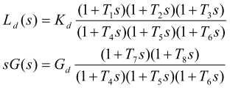

$$R_{a}:Armature resistance$$

$$L_{d,q}\left(s\right) is calculated from Z_{d,q}\left(s\right) operational impedance$$

$$Z_{d}\left(s\right)=\frac{V_{d}\left(s\right)}{I_{d}\left(s\right)} , sG\left(s\right)=\frac{I_{fd}\left(s\right)}{I_{d}\left(s\right)} when the field is short circuited$$

Definition of unknowns ($\overline{x}$) and knowns ( $\overline{y}$: estimated from measured freq. resp. data of the transfer function) of d-axis circuit

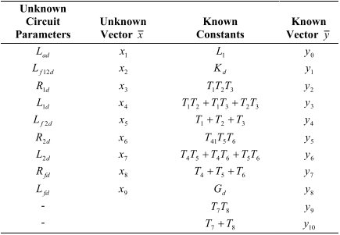

$T_{1},T_{2}, … ,T_{8} :time constants$ estimated by curve fitting technique. The complex nonlinear eq. of $\overline{y}$ is obtained by using MACSYMA, Mathematica, Symbolic Math Toolbox etc. (computer algebra system CAS)

 where, i = 1, … ,10 , ζ : noise associated with each element *yi*

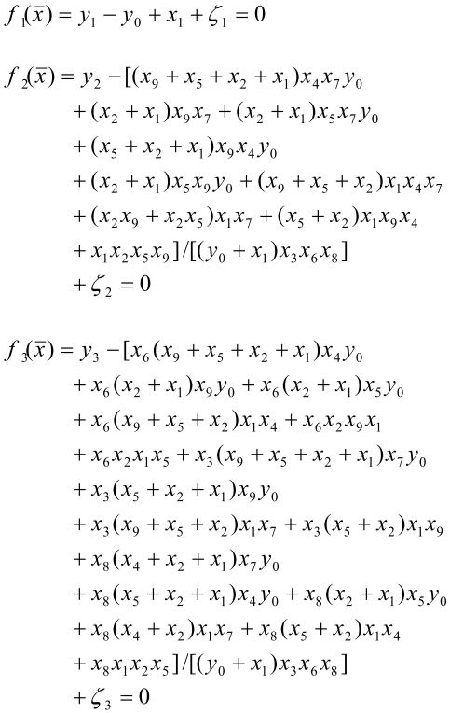 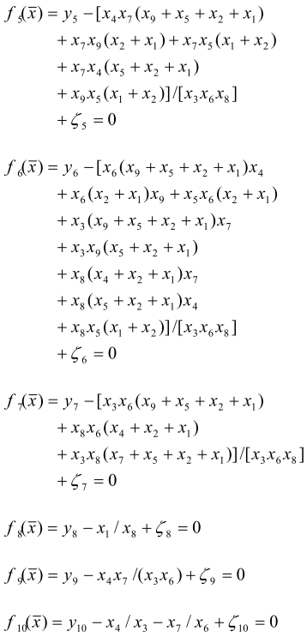 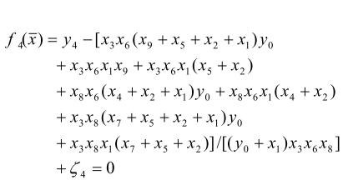

Newton-Raphson method is used for solve these 10 nonlinear eqs. Iteratively. (10 eqs. 9 unknowns : there are multiple solutions depending on which eq is ignored). If the measured freq. resp. data are noise free, ζ i =0 for i=1, … ,10, 10 eqs. Gives unique solution regardless of the ignored eq.

 $F\left(\overline{x}\right)=\left[f_{1}\left(\overline{x}\right), f_{2}\left(\overline{x}\right), …, f_{10}\left(\overline{x}\right)\right]=0 is solved by updating {\overline{x}}^{K+1}={\overline{x}}^{K}+Δ{\overline{x}}^{K} , K=0, 1, 2, …$

until the residuals are smaller than a predetermined error ε ()

Before the iterative approximation can be carried out, a good initial estimate if the unknown vector $\overline{x}$ is essential for convergence to a solution. In this report, the initialization of the unknown vector is performed by using the method developed by [**SD Umans, JA Mallick, GL Wilson, Modeling of solid rotor turbogenerators – Part I: Theory and techniques, IEEE Transactions on Power App. Systems, Vol. PAS-97, No. 1, 1978, Pages 269- 277**]. In his method, $f_{8}(\overline{x})$ is discarded and the remaining nine equations are solved for the nine parameters.

Study …